Hong Kong Exchanges and Clearing Limited and The Stock Exchange of Hong Kong Limited take no responsibility for the contents of this announcement, make no representation as to its accuracy or completeness and expressly disclaim any liability whatsoever for any loss howsoever arising from or in reliance upon the whole or any part of the contents of this announcement.

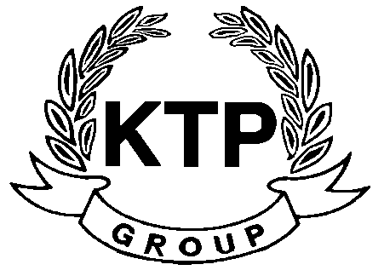
KTP HOLDINGS LIMITED
港台集團有限公司*
(Incorporated in Bermuda with limited liability)
(Stock code: 645)

NOTICE OF BOARD MEETING

The board of directors (the “Board”) of KTP Holdings Limited (the “Company”) hereby announces that a meeting of the Board will be held at 10:00 a.m. on Friday, 18th November 2011 for the purpose of considering and approving the interim results of the Company and its subsidiaries for the six months ended 30th September 2011 and considering the payment of an interim dividend, if any.

By Order of the Board
KTP Holdings Limited
Chua Chun Kay
Chairman
Hong Kong, 8th November 2011

As at the date of this announcement, the executive directors of the Company are Mr. Chua Chun Kay (Chairman) and Mr. David Michael Gormley and the independent non-executive directors are Mr. Lam Pun Yuen, Frank, Mr. Ngan Hing Hon and Mr. Yeung Kin Bond, Sydney.

*For identification purpose only

